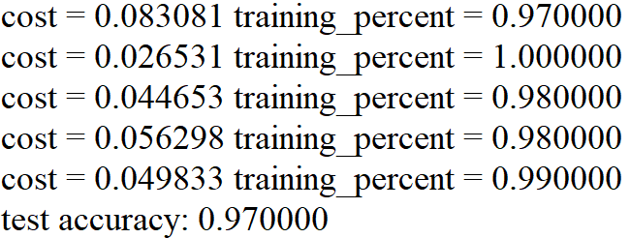3.1

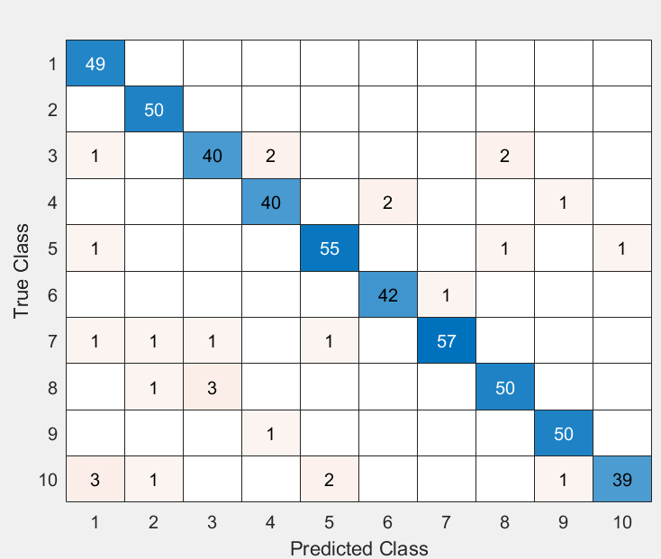3.2

Top two confused pairs of classes are (0, 9) and (2, 7).

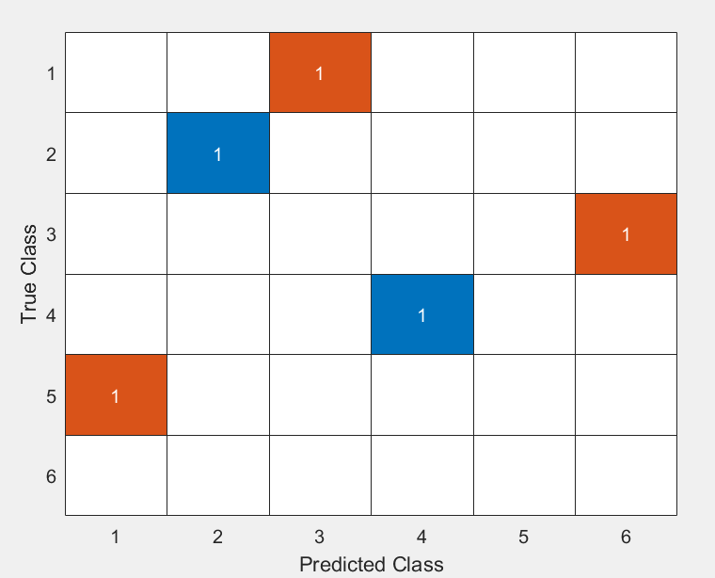3.3

4.1

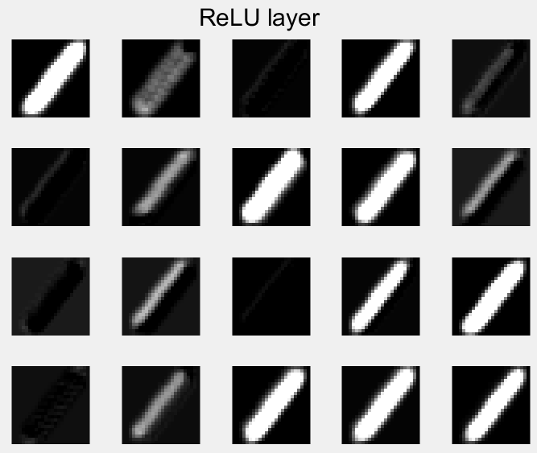

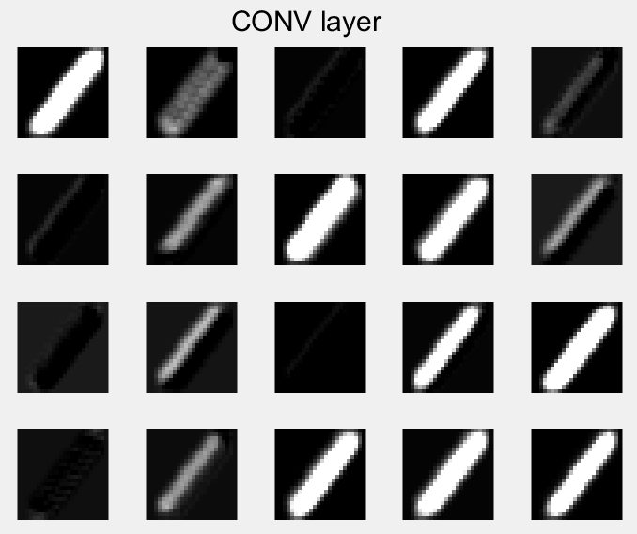

4.2

The CONV layer and ReLU layer have less black area, and less detail than the original image.

5.

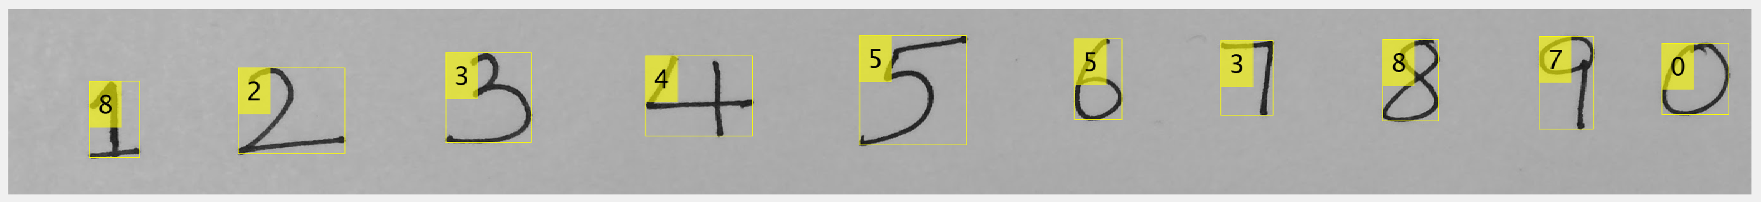

Accuracy: 60%

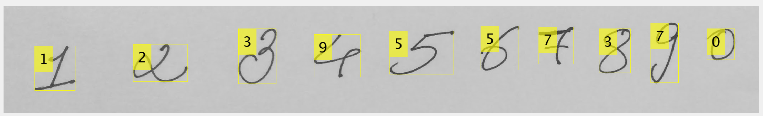

Accuracy: 60%

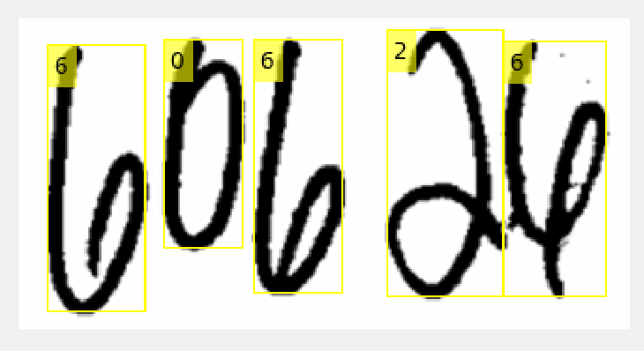

Accuracy: 80%

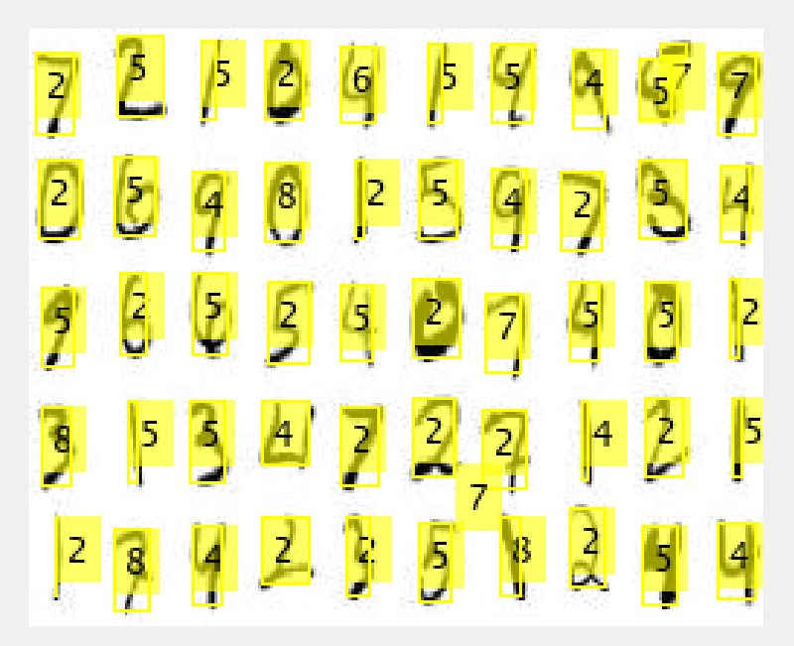

Accuracy: 22%